

MSc in Computer Science - Team Project

User Evaluation Report

Team Name: AI Study Buddy (Group 3)

Anika Mayesha – D24125187
Lorenzo Palleschi – D24126922
Rumaysa Babulkhair – D24125711
Yurii Sykal – C23512523

Table of Contents
MSc in Computer Science - Team Project 1
1. Introduction 4
2. Proposed Hypothesis 5
2.1 Observational Evaluation (Wizard-of-Oz Walkthrough) 6
2.2 Qualitative Questionnaire 6
2.3 Quantitative Questionnaire 6
3. Experimental Method 8
3.1 Overview 8
3.2 Data Collection 8
3.3 Selected Subjects 8
3.3.1 Persona Evolution 9
3.4 Data Analysis 10
3.4.1 In Person Observational Evaluation 10
3.4.2 Qualitative Feedback Analysis 10
3.4.3 System Usability Scale Analysis 11
3.4.4 Think-Aloud Analysis 11
3.5 Practical Setup 11
3.6 Expert Usability Review 12
3.7 Accessibility Evaluation Tools 12
4. User Evaluation Results 14
4.1 Overview of Collected Data 14
4.2 System Usability Scale (SUS) Results 14
4.3 Motivation and Recommendation Ratings 15
4.4 Observational Findings 16
4.5 Qualitative Feedback 17
4.5.1 Thematic Analysis 17
4.5.1 Theme Frequency 19
4.5.2 SOLO Taxonomy Coding 19
4.6 Summary of Results 19
4.7 Limitations 20
4.7.1 Technical Constraints 20
4.7.2 Inflation of Usability Perceptions 20
4.7.3 Limited Sample Size 20
4.8 Ethical Considerations 20
5. Conclusions 21
References 22
Appendices 23
Appendix A – Personas 23
Persona 1: Typical Student 23
Persona 2: Potential Evolution for Professor 24
Appendix B – System Usability Scale (SUS) 24
Appendix C – Interface Updates 27
Dashboard Update 27
Module Selection 28
Landing Page (Figma) 28
Appendix D – Data Tables and Charts 29
Solo Taxonomy 29
Appendix E – Future Testing 29
Cognitive Task Completion / Time Taken 29
Appendix F – Survey 30

Introduction
A user evaluation is fundamental process of any product’s design, which effectively assesses how real users interact with a system to achieve their specific goals. It also allows the designers to get a good grasp of any design issues, highlighting the needs and wants of the user. In Human-Computer interaction (HCI), it is defined as identifying usability issues, measuring user satisfaction, and the validation of whether the system meets its intended purpose (Nielsen, 1994; Tullis & Albert, 2013).
The evaluation process typically comprises of both quantitative (e.g., task completion time, error rates, and usability scores), along with qualitative (users’ perceptions, emotions, and preferences). In the case of this project, the AI Study Buddy, the evaluation broadens past usability, and also assesses the learning effectiveness, motivation, and cognitive engagement (Bloom, 1956; Biggs & Collis, 1982).
For this project, the application is designed to centralise numerous features that would be helpful for a student, such as summarisation, flashcards, quizzes, and learning analytics; as such, the evaluation was primarily done to assess usability, accessibility, and the educational value. Therefore, various methods were used to achieve the desired evaluation results, such as:
- Persona-Driven Development – To aid in the development of the system, a number of fabricated user archetypes were developed.
- Expert Usability Feedback – To ensure that the system was designed in a manner congruent with UX practice, an expert in UX reviewed early interface designs.
- Wizard-of-Oz Walkthrough – In-person observational testing which assesses the ease of which a new user can complete their task.
- Retrospective Think-Aloud sessions – To capture a user’s thought process during their testing which is documented at the time and reflected on later.
- Questionnaires – For both a qualitative open-ended feedback method and a quantitative Likert-scale response system to measure usability.

A key testing phase was done with a class-group of postgraduate students. It was primarily focused on the assessment of usability and the perceived usefulness rather than the learning improvement (which would require more longitudinal testing). These results will guide the future development of AI Study Buddy, ensuring that the interface and functionality align with real-world students learning behaviours. The future testing will be done to measure students learning improvements from the initial testing as the students have more time to interact with the system.

Proposed Hypothesis
The first-stage of this evaluation is aimed at the following research questions:
- Can the users intuitively complete the common study tasks within AI Study Buddy?
- Do the users find the interface and icons to be clear and consistent?
- Does the system serve as an effective centralised study space?

Hypotheses
- H1: The participants will perceive ≥ 85% of the demonstrated tasks as clear and intuitive.
- H2: Mean System Usability Scale (SUS) score of ≥ 80 (“Excellent”).
- H3: ≥ 70% of the users describe the application as motivating.

As aforementioned, although the single-session evaluation is unable to directly measure learning gains, the data gathered will be useful for establishing usability and engagement baselines. The secondary future evaluation will likely include pre / post-tests alongside a longitudinal analysis to assess the students learning improvements.

As of 2024, the reported data shows that 63% of Irish university students utilise studying apps (Infrastructure, 2024) whilst 83% of secondary level students reported difficulty concentrating due to smartphone distractions (Irish Times, 2023). With this in mind, the use of a focused studying environment helps address these issues for both, current and future third level students. It’s also worth noting that whilst undergraduates spend more time in taught studies, postgraduates tend to spend more time with personal studies (Eurostudent, 2022).

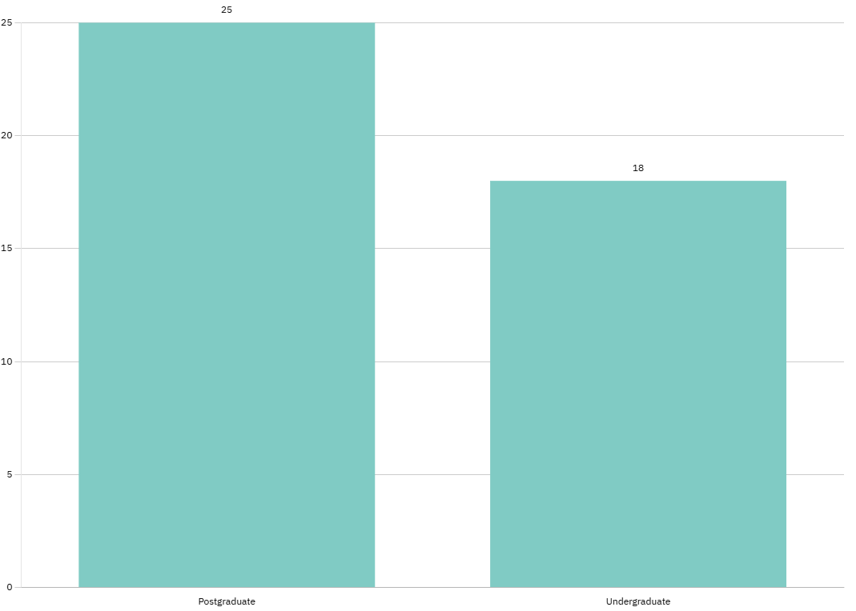
Figure 1: Irish Personal Study Hours Average

Observational Evaluation (Wizard-of-Oz Walkthrough)
A class-group of 19 Masters’ students undertaking a postgraduate degree in Sports Analytics were selected to review the prototype of the system using convenience sampling. Although the original process was planned to use a cognitive walkthrough approach, due to technical issues, which we believe the university firewall prevented the live application from running correctly during this test. As such, we adapted to an in-person observational evaluation instead. Rather than completing the tasks directly, the participants were led through a structured presentation which showcased the core functionality of AI Study Buddy, which is as follows:
1: Register and access the dashboard
2: Upload a PDF of your notes for summarisation
3: Use the focus timer
4: Interact with the AI assistant
5: Generate a flashcard
As each feature was presented, each participant was given a pen and paper to record their immediate thoughts, confusions, and suggestions. These notes were then discussed after the presentation concluded. Whilst this adaptation did limit the measurement of our live task performance (e.g., completion time), it did maintain the usability and comprehension focus of the walkthrough, capturing the user perceptions, and their anticipated ease of use.

Qualitative Questionnaire
Open-ended questions which are asked after the walkthrough concludes, encourage the participants to express any of their frustrations, improvements, or perceptions. Question 4. Also implements Think, Pair, Share, where small groups are formed and given 120 seconds to decide on any features that would be beneficial for the application.
1: What was the most useful feature? Why?
2: Was any aspect too complex?
3: Were any icons or labels unclear?
4: What features do you think are missing from AI Study Buddy?
5: Did you have any issues using AI Study Buddy, e.g., Accessibility Issues, Technical problems etc…?
6: Would you use this application regularly?

Quantitative Questionnaire
To measure the perceived usability, the System Usability Scale (SUS) is utilised (Brooke, 1996). The SUS is made up of ten core, and two personalised ending questions, which are rated on a five-point Likert scale. These questions not only provide the usability data for the SUS score, but also the motivational perception data which come together to address hypotheses H1-H3. It is also worth noting that any questions marked with an (R) are rated in reverse (hidden from the participants), which prevents a response bias by encouraging critical thinking.

Likert scale (1 = Strongly Disagree | 5 = Strongly Agree):
Question Number | Question | 1-5 Rating
1 | I think that I would like to use this system frequently | 
2 | I found the system unnecessarily complex. (R) | 
3 | I thought the system was easy to use. | 
4 | I think that I would need the support of a technical person to use this system. (R) | 
5 | I found the various functions in this system were well integrated. | 
6 | I thought there was too much inconsistency in this system. (R) | 
7 | I would imagine that most people would learn to use this system very quickly. | 
8 | I found the system very cumbersome to use. (R) | 
9 | I felt very confident using the system. | 
10 | I needed to learn a lot of things before I could get going with this system. (R) | 
11 | If I used AI Study Buddy a few times, I think it might motivate me to study more often. | 
12 | I would recommend AI Study Buddy to other people. | 
Table 1: Quantitative Questionnaire

Experimental Method

Overview
The experiment is run with the use of multiple methodologies; combining a qualitative observation and quantitative measurement approach. This was done through the use of an adapted in-person observational evaluation, and the standardised System Usability Scale (SUS) questionnaire.
(It’s worth noting that future quantitative and qualitative testing will be based on task completion, SUS scores, think-aloud, and comments upon the live demo working).
As the live prototype was inaccessible due to the universities firewall restrictions, the participants were shown a guided presentation of the five core tasks (shown in 2.1). The participants noted down any questions or confusions, and addressed them to the demonstrators after the presentation concluded. After which, the questionnaire was assigned to the participants.
The framework aligned the results based on Kirkpatrick Level 1 (Reaction) and Level 2 (Learning perception), with the future testing iterations covering levels 3-4 (Behaviour and Results).

Metric | Baseline Target | Framework
SUS Score | ≥ 80 (Excellent) | Kirkpatrick L1 - Reaction
Perceived Clarity | ≥ 85% | HCI Usability
Motivation Score | ≥ 70% | Kirkpatrick L2 - Learning
SOLO Coding | Relational or greater | Solo Taxonomy
Table 2: Evaluation Overview

3.2 Data Collection
The survey data collected was recorded via Google forms, and processed into Excel for analysis. It is as aforementioned, measured in both quantitative and qualitative in the following manners:
Qualitative: Open ended responses, and retrospective think-aloud commenting. With observers also documenting their perceived accessibility or technical issues.
Quantitative: Collected via Google Forms, covering SUS scoring, and motivational rating. The SUS scoring utilises the Likert scale of (1-5) for each question.

3.3 Selected Subjects
The system can be used in a rather broad manner, although initially designed for third-level students; its usage can be broadened to even consider the professors. The initial personas were created based on undergraduate students; however, the first round of feature testing was done on a class of postgraduate students. This still represents our initial demographic well, as they are ultimately students which aim to increase their learning capabilities. 19 testers familiar with AI gen learning, were sourced thanks to our professor Damian Gordon, who provided a class of his students to test out the application; however, only 11 participated in the full questionnaire.
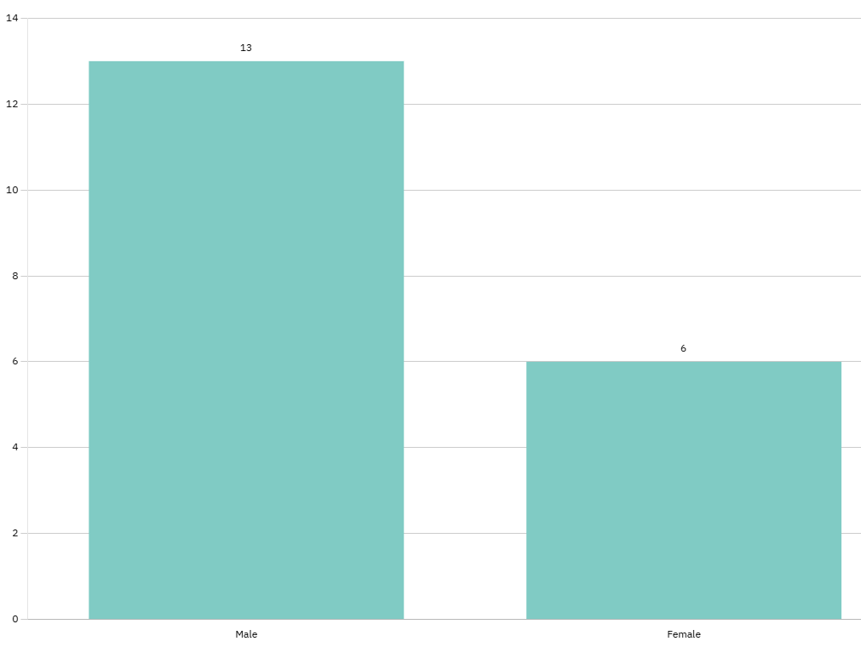
Figure 2: Participant Quantity and Gender

3.3.1 Persona Evolution
As the personas were developed in the early stages of the project, they played an essential part in shaping the design and evaluation process of AI Study Buddy. They were representative of a diverse set of undergraduate students in various age groups, technical skills, and studies.
As the system evolves, these personas will likely evolve, with future design stages incorporating additional personas that have different attributes. This could range from covering simply being a postgraduate student, a professor or having various accessibility needs e.g., visual impairments. With this persona-driven approach, it is assured that the system remains inclusive and aligns with any requirements that an expanding userbase would have.

Data Analysis

In Person Observational Evaluation
This Wizard-of-Oz Walkthrough assesses how easily a first-time user may navigate and utilise the system without prior instruction. With the participants simply going off of a core task list, as they think-aloud, any design obstacles will are documented to assess the systems learnability.
Each task is scored based on its success, failures, completion time, and observed errors; with the desired overall success rate being ≥ 85%.
Feature | Perceived  Clarity (%) | Sample  Feedback
Register | 95 | Clear, no issue
Upload PDF | 88 | Add a drag-and-drop option
Use Focus Timer | 90 | Helpful but not visible enough
Interact w/ AI Assistant | 85 | Could be adjustable sized window
Generate a flashcard | 82 | Add error tracking and an export feature
Table 3: Sample Observational Evaluation Results
As there were no live timings recorded, the perceived clarity is used, as it aligns closely with task success rate. With ≥ 85% clarity overall, this system would demonstrate an “excellent” rating for perceived usability, meeting our H1.

3.4.2 Qualitative Feedback Analysis
The (6) five questions gave open-ended responses which were analysed with the use of thematic analysis (Braun & Clarke, 2006) and then classified using SOLO Taxonomy (Biggs & Collis, 1982). The themes are based around the usability, aesthetics, accessibility, and the motivation of the application.
SOLO Level | Description | Sample Comment
Uni-Structural | Basic observation | “The layout is nice”
Multi-Structural | Various features listed | “It’s easy to summaries notes and use flashcards”
Relational | Connected understanding | “The summary helps me remember facts for my quizzes”
Extended Abstract | Comparative reflection | “This could replace many other studying tools”
Table 4: Sample SOLO coding
This analysis captures a user’s understanding of the application, rather than simply their satisfaction levels. With the feedback being mapped to SOLO levels, we can deduce whether the participant understands the educational value of AI Study Buddy rather than just its usability.

3.4.3 System Usability Scale Analysis
The System Usability Scale (SUS) is a well validated quantitative measure of usability across ten items (Brooke, 1996). The scores range from 0-100, where the benchmark of 68 represents “average” usability, and 80+ at an “excellent” level (Lewis, 2018).
The SUS captures both a user’s subjective satisfaction and their ease of use; these two factors are strong indicators of a user’s long-term adoption (Sauro & Lewis, 2016). With the initial 10 questions being a standardised method, it also allows AI Study Buddy’s usability to be compared to that of various other established applications. A high SUS score is representative of efficient design, clear navigation, and a low learning curve, all of these factors are crucial to retain engagement, especially within an educational tool.

3.4.4 Think-Aloud Analysis
As the users did not verbalise in real time, this segment became more of a retrospective think-aloud or written reflection. The participants reactions were documented and later on, elaborated on verbally. This method still gave us great insight into any perceived usability issues, and the intuitive understanding of the interfaces’ flow.

3.5 Practical Setup

Participants
The first goal to accomplish was to test participants which were representative of our user personas, which were created early in the project life cycle. These are third level students with various studying habits and technical abilities. The participants acquired fit nicely within these criteria, 19 were selected for the testing with 11 fully completing all sections.

Environment
The evaluation itself was conducted in-person within a quiet classroom. As the firewall caused issues with our localised model, the session was instead performed as a guided presentation rather than live prototype interaction. The participants were shown a demo of five core features of a typical user journey: user registration, note uploading and summarisation, activation of the pomodoro timer, interacting with the AI assistant, and finishing with the generation of a flashcard.

Procedure and Instructions
Before the session began, the participants were briefed on why the system exists, and the undergoing evaluation process. For the feature demonstration, they were instructed to take short notes, focused on the clarity, complexity, and usefulness.

Data Collection
After the presentation, the participants were then provided an online questionnaire via Google Forms, which ran through both the qualitative and quantitative questions. These forms recorded the responses so that we could later process the data thematically.

Expert Usability Review
Prior to conducting the user evaluation, the interface was subjected to expert criticism under a usability review from our professor Andrea. The review was focused on identifying numerous issues including the consistency, visibility of system status, error prevention, functionality, and general aesthetic design.
Feedback was received for both the applications itself, and many of the developed Figma prototype screens, with suggestions made to implement various features from those Figma prototypes e.g., the search bar to assist in navigation. There were many other suggestions, particularly regarding the general interface, and colour scheme. Unfortunately, in order to get the application in a better state, priorities were set on feature development rather than implementing a lot of this feedback; however, this expert review did have the suggestions noted and will be implemented for future testing.

Accessibility Evaluation Tools
To complement the participant-based testing and the expert usability review, there are numerous automated accessibility tools which were considered to test the interface against various recognised standards. These tools help identify the structural, visual, and navigational issues which may hinder a user, especially those with accessible needs e.g., colour-blind, screen readers.
In this case, WAVE WebAIM’s evaluation tool and W3C colour contrast checker were selected to help identify any missing ARIA labels, poorly structured headings, any low-contrast elements and other violations of the WCAG 2.1 guidelines. There are future considerations to be made for IBM’s equal accessibility checker, which provides detailed code level insights, highlighting any potential accessibility barriers within the interactive components e.g., buttons, forms etc…
Although these tools are not our basis for evaluation, they do offer valuable analysis support for our user testing sessions. As there are numerous interface updates to come, these tools will ensure that AI Study Buddy retains a compliant approach to usability standards and remains accessible to a broad range of learners.

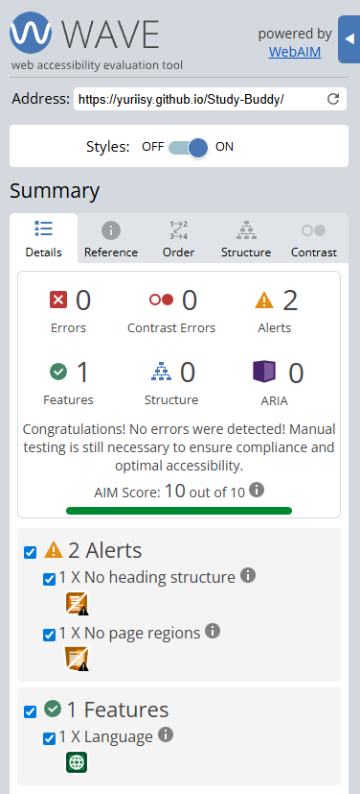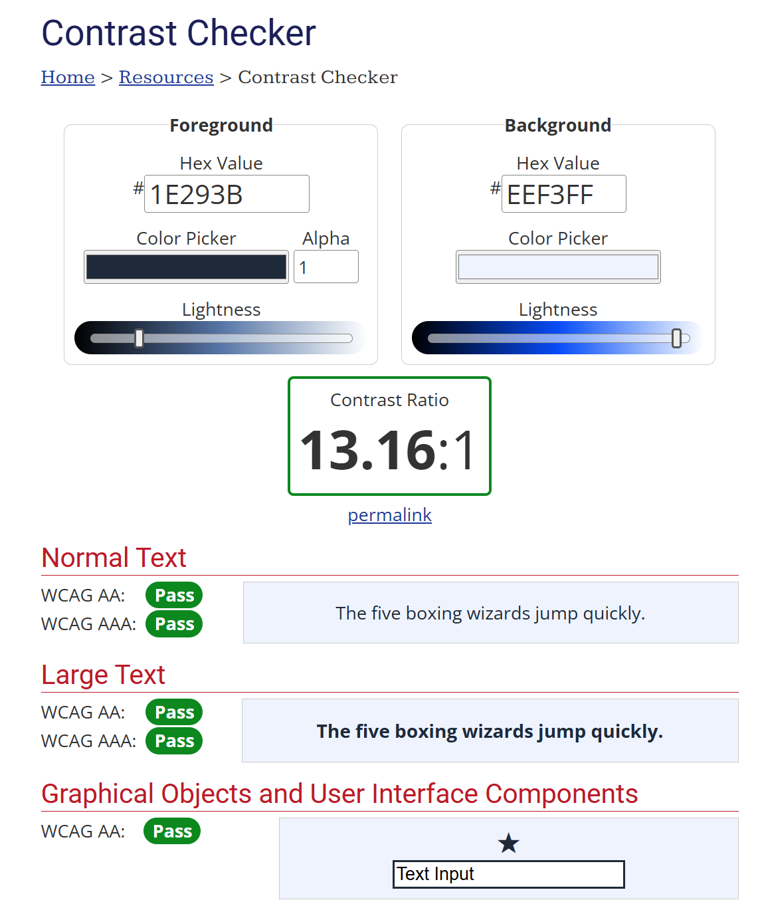
Figure 3: Accessibility Tools

4. User Evaluation Results

Overview of Collected Data
The relevant quantitative and qualitative data was limited to the 11 participants who underwent the google form process. This covers the System Usability Scale (SUS) questions, motivation and recommendation items, along with the six five open-ended qualitative questions. The results are summarised in the following sections, with a combination of numeric metrics, and thematic analysis to capture the usability and engagement.

System Usability Scale (SUS) Results
Participant | SUS Score
P1 | 100
P2 | 82.5
P3 | 67.5
P4 | 77.5
P5 | 77.5
P6 | 100
P7 | 87.5
P8 | 87.5
P9 | 82.5
P10 | 100
P11 | 67.5
Table 5: SUS Results
Mean SUS: 84.1
Standard Deviation: 11.7
Benchmark: 80 “Excellent”

AI Study Buddy has a rated SUS score of 84.1 which places it within the “Excellent” range (Brooke, 1996). With a score above 80, it indicates that the users found the interface to be intuitive and cohesive, without users being confused when viewing through the showcased features. Whilst this may seem impressive, the fact that it was guided, along with a low count, likely led to some discrepancy in results, where future testing will likely provide a more accurate data sample by raising the participant number and having them use the prototype.
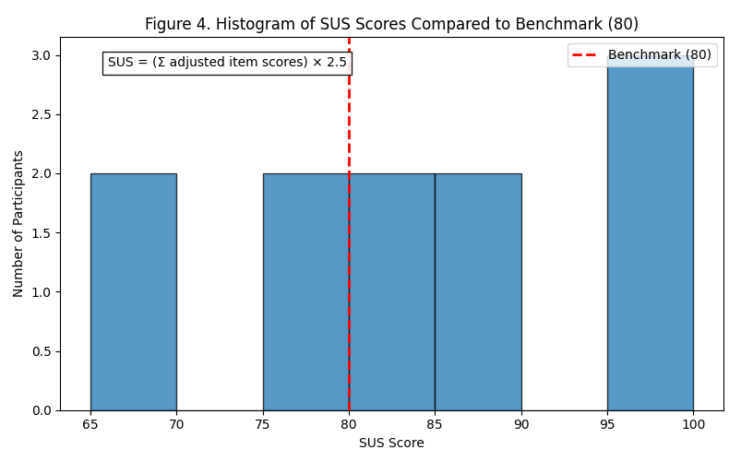
Figure 4: SUS Scores vs Benchmark

Motivation and Recommendation Ratings
These two unique questions were useful to analyse how useful the participants found AI Study Buddy, as there was a strong willingness to recommend it along with a perceived increase to their studying motivation. This falls under Kirkpatrick’s Level 2 (Learning) which helps ensure that our engagement remains positive within learning support systems.
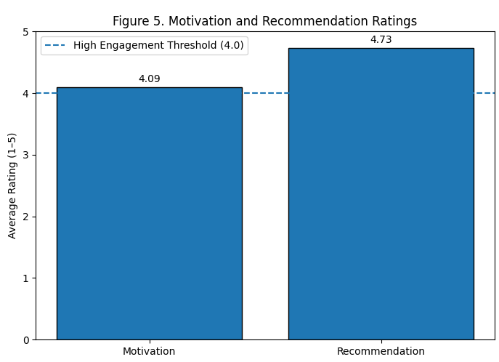
Figure 5: Motivation and Recommendation Ratings

Observational Findings
With the guided evaluation, the participants were set to observe and reflect on five primary tasks. The perceived clarity and feedback are summarised below.
Feature | Perceived Clarity (%+) | Observations
Register | 95 | Straightforward, perhaps introduction text to be added.
Upload Notes | 88 | Clear, was a request for drag and drop, along with better file status displaying.
Focus Timer | 90 | Effective, but complaints about colour blending.
AI Assistant | 85 | Useful for summaries, maybe flexibility in panel sizing
Flashcards | 82 | Nice interactivity, but requests for “missed questions”
Table 6: Observational Findings
The overall clarity was greater than 85%, which meets the H1 standard we aimed for. The received feedback showcases that the users understood the core workflow, although they may have wanted more personalisation and interface updates.

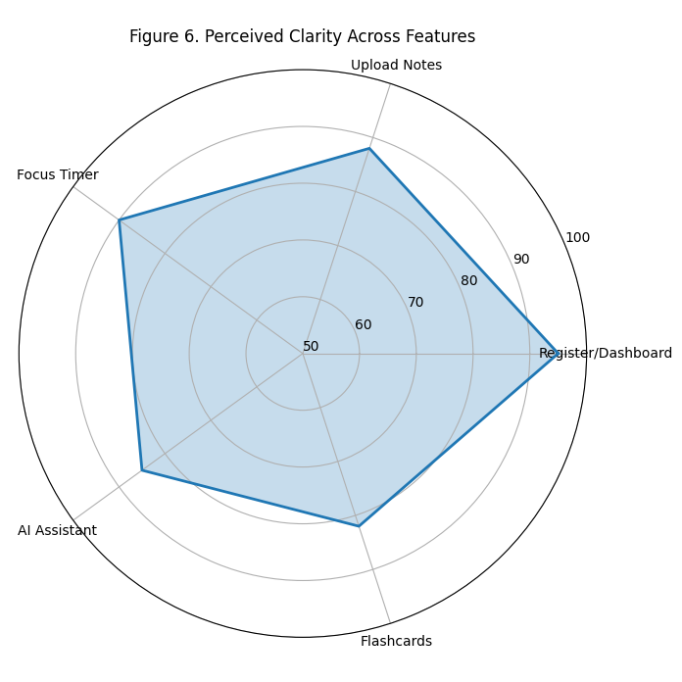
Figure 6: Perceived Clarity Radar Chart

Qualitative Feedback
With the extensive responses gathered from the qualitative analysis, there are numerous responses which can be applied to a thematic analysis. These help identify user perceptions, clarity, complexity, any missing features, and accessibility issues.

4.5.1 Thematic Analysis
Theme 1: Showed that participants could decide on their favourite features, typically on the tools which reduce cognitive load.
Theme 2: The participants didn’t report any substantial complexity, but recommended some visual improvements.
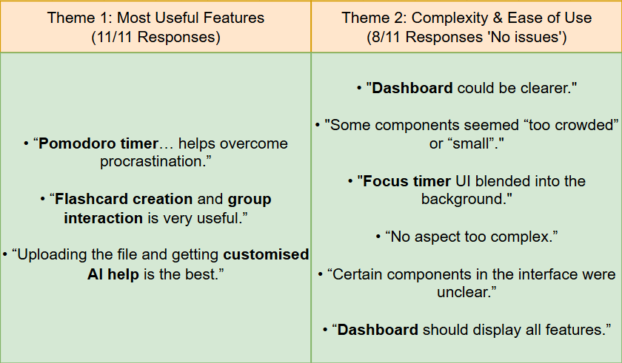
Figure 7: Theme 1 & Theme 2

Theme 3: Some minor confusions were noted, particularly with the sizing.
Theme 4: This theme gave us the most insight, and showed that users want a lot more personalisation, progress tracking, and additional study supportive features.
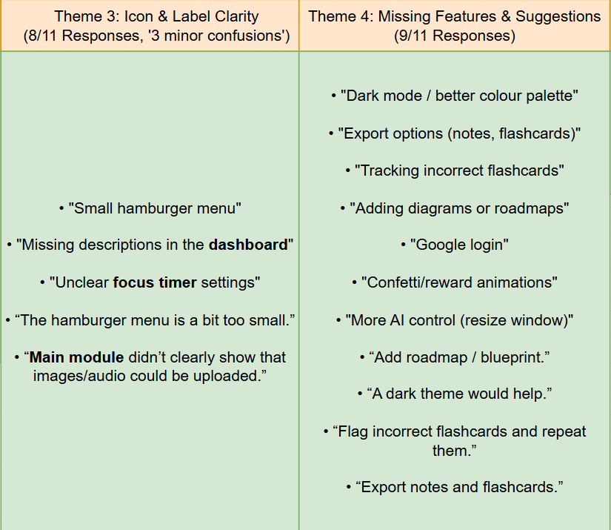
Figure 8: Theme 3 & Theme 4
Theme 5: There were not any listed major accessibility issues (expected due to guided walkthrough), design interfacing feedback was given for potential accessibility e.g., contrasting.
Theme 6: With most users indicating that they would use the system regularly, we are pleased with the feedback and progress the application is making.
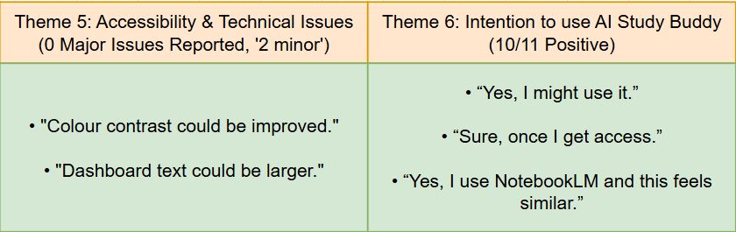
Figure 9: Theme 5 & Theme 6

Theme Frequency
Theme | Frequency | % of Users
Most useful feature identified | 11 | 100%
Complexity issues | 3 | 27%
Icon or label confusion | 3 | 27%
Missing features identified | 9 | 82%
Accessibility/technical issues | 2 minors | 18%
Would use regularly | 10 | 91%
Table 7: Theme Frequency

SOLO Taxonomy Coding
Each of the qualitative responses was evaluated with the use of SOLO Taxonomy to determine the cognitive depth.
SOLO Level | Count | Example
Uni-Structural | 2 | “Flashcards were useful”
Multi-Structural | 5 | Several missing features or reasons for usefulness
Relational | 3 | Connects the features to studying habits
Extended Abstract | 1 | Suggested structural improvements which were tied to learning outcomes (e.g., blueprint roadmap)
Table 8: Solo Taxonomy
82% of the responses reached multi-structural or higher, this indicates that the engagement was meaningful when it comes to the systems educational utility.

Summary of Results
Category | Result | Outcome
Usability (SUS) | 84.1 | Excellent
Motivation | 4.09 / 5 | High
Recommendation | 4.73 / 5 | Very High
Perceived Clarity | 85-95% | Excellent
Feature Requests | Dark mode, exporting flashcards… | Future additions
Table 9: Summary of Results
Ultimately, AI Study Buddy met all of the hypotheses (H1-H3). The usability and motivation results help confirm that the user flow works smoothly, whilst the qualitative themes identify any helpful enhancements which could be made for future iterations.

4.7 Limitations
While the user evaluation provided valuable insights into the usability and perceived effectiveness of AI Study Buddy, several limitations must be acknowledged when interpreting the findings. These constraints relate primarily to methodological adjustments, sample characteristics, and the restricted nature of the prototype used during the session.

4.7.1 Technical Constraints
The planned cognitive walkthrough with a live prototype could not be conducted due to university firewall restrictions preventing the application from running. As a result, the evaluation was adapted into a guided, presentation-based walkthrough using static screens rather than direct user interaction. This adaptation limited the ecological validity of the findings, as participants did not engage in genuine hands-on task completion. Because users were shown each step, potential usability issues related to discoverability, navigation, or error recovery were not observable.

Inflation of Usability Perceptions
The guided nature of the walkthrough may have contributed to positively biased usability scores. Participants did not independently explore the interface, and the presence of facilitators likely minimised confusion and cognitive load. As a result, the System Usability Scale (SUS) score of 84.1 may be artificially elevated compared to results from a fully interactive, unguided session.

Limited Sample Size
Although 19 participants attended the session, only 11 completed the full questionnaire, reducing the reliability and representativeness of the results. Furthermore, convenience sampling was used, with participants drawn from a single postgraduate class in Sports Analytics. This group may not reflect the broader target user population, such as undergraduates, diverse academic disciplines, or users with varying levels of digital literacy.

4.8 Ethical Considerations
The user evaluation followed standard ethical principles to ensure participant safety, privacy, and autonomy. All participants were informed about the study’s purpose, the prototype being demonstrated, and the nature of the data collected. Participation was fully voluntary, and individuals could withdraw at any time. No personally identifiable information was gathered, and all questionnaire responses were anonymous. Data was stored securely and used solely for academic analysis within this project. The guided walkthrough posed minimal risk, as it involved no sensitive content or invasive procedures. Participants were encouraged to provide honest feedback without pressure, and the classroom environment ensured a safe and controlled setting. Because the study involved anonymised, low-risk interaction and was conducted for educational purposes only, formal institutional ethics approval was not required. Nonetheless, the evaluation adhered to general research integrity standards and prioritised responsible data handling, confidentiality, and respect for participant autonomy throughout.

Conclusions
Ultimately, the user evaluation of AI Study Buddy produced strong evidence in support of the systems usability, clarity, and educational prowess. Although the walkthrough was done in a guided manner due to technical restrictions which blocked the live demo, the combined findings from the SUS questionnaire, motivational measures, observational commentary, and the qualitative responses do demonstrate that the tool performs well across various user experience dimensions. The evaluation also supports several of the initial hypotheses (H1-H3), showcasing that the system was easy to use, that the main features could be used without instruction, and that the application was perceived as a useful studying aid.

With a SUS score of 84.1, the system is placed in the “excellent” range, putting it above-average in a usability manner when compared to other benchmarks. The qualitative feedback helped reinforce these results, where the participants highlight the usefulness of various features such as the pomodoro timer, or summarisation. The observational data also showed a high perceived clarity across our core features, although some issues were noted particularly regarding the UI (icon size, colour contrast). It’s worth noting that a walkthrough being done, rather than fully interactive prototype can skewer results slightly, and this limitation should be considered when processing the data.

Future evaluations will address this issue by having the system in a hosted environment rather than locally, which will bypass the firewall issues faced prior. This not only allows genuine task-based interaction, but also allows us to utilise various performance metrics such as task completion time, navigational patterns, and error rates. As more features are added, and visual refinements are implemented, further rounds of testing will be performed; this allows for longitudinal studies giving us a deeper analysis of the learning impact, motivation, and long-term adoption.

In conclusion, the evaluation confirms that AI Study Buddy has a strong basis, and with continued development following the mentioned methods, the system will become a highly effective application for enhancing a learners’ studies.

References
Ardent Learning (2024): What is the Kirkpatrick Model? Retrieved from: https://www.ardentlearning.com/blog/what-is-the-kirkpatrick-model
Biggs, J. B., & Collis, K. F. (1982): Evaluating the Quality of Learning: The SOLO Taxonomy (Structure of Observed Learning Outcomes). Retrieved from: https://www.sciencedirect.com/book/9780120975525/evaluating-the-quality-of-learning
Bloom, B. S. (1956): Taxonomy of Educational Objectives: The Classification of Educational Goals. Retrieved from: https://eclass.uoa.gr/modules/document/file.php/PPP242/Benjamin%20S.%20Bloom%20-%20Taxonomy%20of%20Educational%20Objectives,%20Handbook%201_%20Cognitive%20Domain-Addison%20Wesley%20Publishing%20Company%20(1956).pdf
Braun, V., & Clarke, V. (2006): Using Thematic Analysis in Psychology. Qualitative Research in Psychology. Retrieved from: https://doi.org/10.1191/1478088706qp063oa
Brooke, J. (1996): SUS: A Quick and Dirty Usability Scale. In P. W. Jordan, B. Thomas, B. A. Weerdmeester, & A. L. McClelland (Eds.), Usability Evaluation in Industry. Retrieved from: https://www.scirp.org/reference/referencespapers?referenceid=3307463
Dalrymple, D. (2018): Cognitive Walkthroughs Explained. Medium. Retrieved from: https://medium.com/@dalrymple/cognitive-walkthroughs-explained
Gordon, D. (2023): SOLO Taxonomy (Structure of Observed Learning Outcomes). Damian Gordon. Retrieved from: https://www.damiantgordon.com/EducationalModels/CriticalThinking/SOLO/
Gordon, D. (2023): Bloom’s Taxonomy of Educational Objectives. Damian Gordon. Retrieved from: https://www.damiantgordon.com/EducationalModels/CriticalThinking/BloomsTaxonomy/index.html
Higher Education Authority (2022): Student Survey Report: Learning Habits and Engagement. Higher Education Authority. Retrieved from: https://hea.ie
Instructure (2024): Irish Students and Digital Learning Survey. Retrieved from: https://www.instructure.com
Irish Times (2023): Overuse of Smartphones Ruining Ability to Study, Say Educators. The Irish Times. Retrieved from: https://www.irishtimes.com
Kirkpatrick, D. L., & Kirkpatrick, J. D. (2006): Evaluating Training Programs: The Four Levels. Retrieved from: https://www.scirp.org/reference/referencespapers?referenceid=2702697
Lewis, J. R. (2018): The System Usability Scale: Past, Present, and Future. Retrieved from: https://www.researchgate.net/publication/324116412_The_System_Usability_Scale_Past_Present_and_Future
Nielsen, J. (1994): Usability Engineering. Retrieved from: https://dl.acm.org/doi/book/10.5555/2821575
Tullis, T., & Albert, W. (2013): Measuring the User Experience: Collecting, Analyzing, and Presenting Usability Metrics. Retrieved from: https://www.researchgate.net/publication/230786766_Measuring_the_User_Experience_Collecting_Analyzing_and_Presenting_Usability_Metrics_Second_Edition
World Wide Web Consortium (2018): Web Content Accessibility Guidelines (WCAG) 2.1. Retrieved from: https://www.w3.org/TR/WCAG21/
Zimmerman, B. J. (2002): Becoming a Self-Regulated Learner: An Overview. Theory Into Practice. Retrieved from: https://doi.org/10.1207/s15430421tip4102_2
Eurostudent, Higher Education Authority (2023): Eurostudent VIII. Retrieved from: https://www.eurostudent.eu/download_files/documents/Eurostudent-8-final-report_IE.pdf

Appendices

Appendix A – Personas

Persona 1: Typical Student
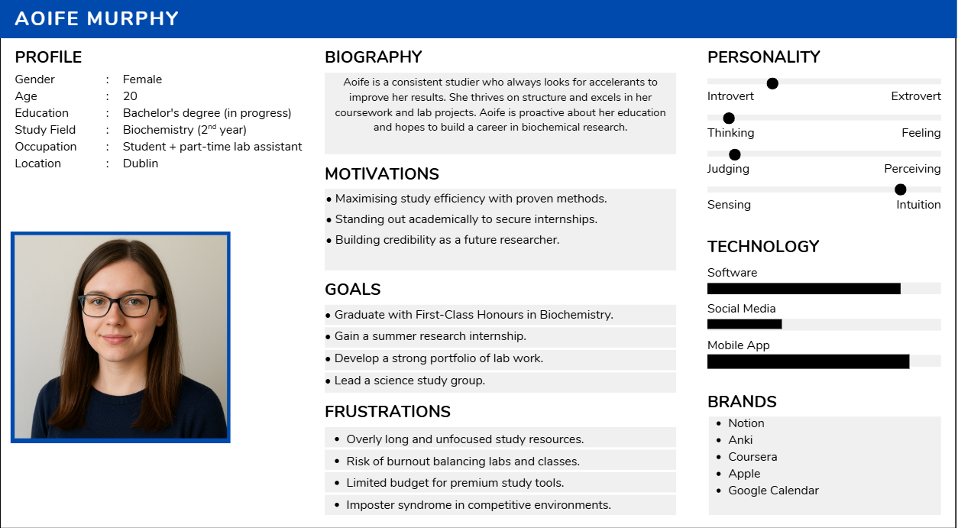

Persona 2: Potential Evolution for Professor
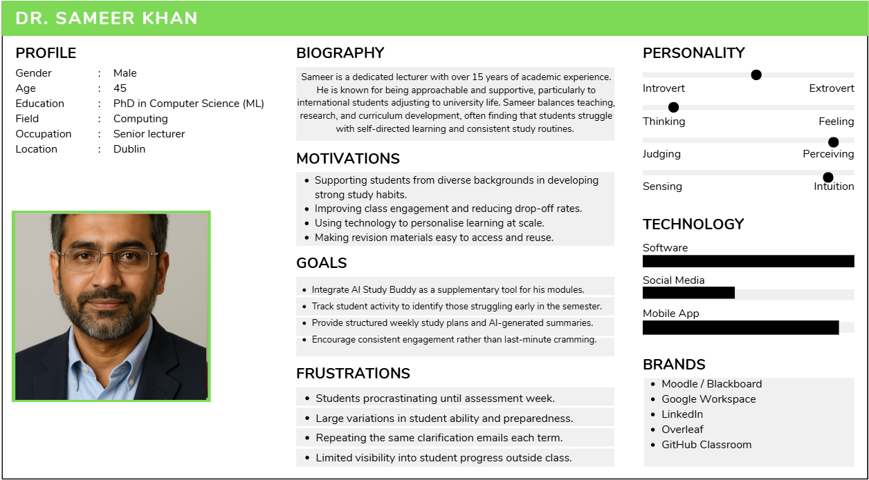

Appendix B – System Usability Scale (SUS)
The System Usability Scale (SUS) (Brooke, 1996) consists of ten statements rated on a 5-point Likert scale where:
(1 = Strongly Disagree & 5 = Strongly Agree).
Responses are later converted into numerical values (0–4) using the procedure below.
Number | SUS Statement | Polarity | Scoring rule | Sample Response | Adjusted Score
1 | I think that I would like to use this system frequently. | + | (response -1) | 4 | 3
2 | I found the system unnecessarily complex. | - | (5 – response) | 2 | 3
3 | I thought the system was easy to use. | + | (response -1) | 5 | 4
4 | I think that I would need the support of a technical person to use this system. | - | (5 – response) | 3 | 2
5 | I found the various functions in this system were well integrated. | + | (response -1) | 4 | 3
6 | I thought there was too much inconsistency in this system. | - | (5 – response) | 2 | 3
7 | I would imagine that most people would learn to use this system very quickly. | + | (response -1) | 5 | 4
8 | I found the system very cumbersome to use. | - | (5 – response) | 1 | 4
9 | I felt very confident using the system. | + | (response -1) | 4 | 3
10 | I needed to learn a lot of things before I could get going with this system. | - | (5 – response) | 2 | 3
Table 10: System Usability Scale Rating Process

SUS Calculation Formula
$$\text{SUS Score}=(\sum_{i=1}^{10}{}\text{Adjusted Scores})×2.5$$
Each participant’s total ranges from 0 to 100.

Interpretation Guide
SUS Score Range | Interpretation | Grade Equivalent
> 80.3 | Excellent (usability above industry benchmark) | A
68–80 | Good (average to above average) | B–C
50–67 | Marginal | D
< 50 | Poor | F
(Lewis, 2018; Sauro & Lewis, 2016)

Example
If a participant’s adjusted scores sum to 33:
then 33 x 2.5 = 82.5. So, the SUS = 82.5, which represents “excellent” usability. NOTE: As there are two bonus questions added for our application, they will be considered outside of the standardised process, to retain competitiveness with other applications.

Appendix C – Interface Updates

Dashboard Update
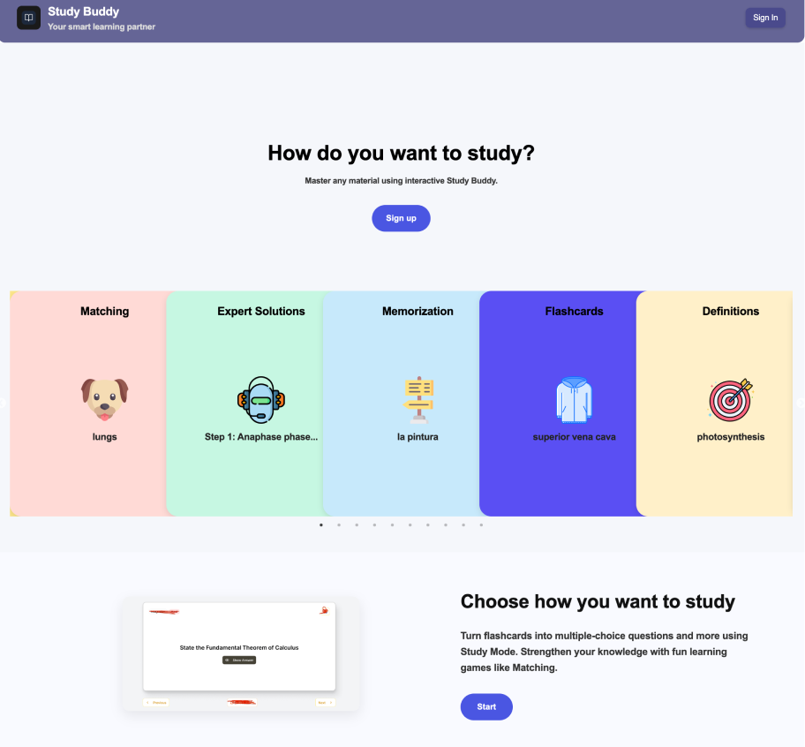

Module Selection
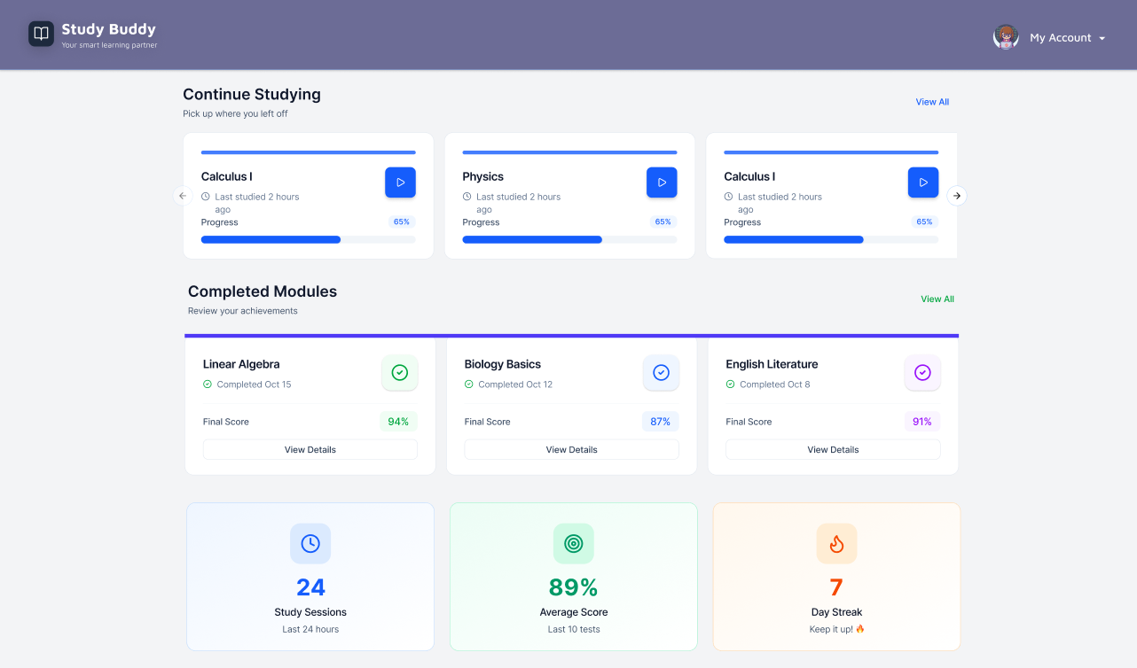

Landing Page (Figma)
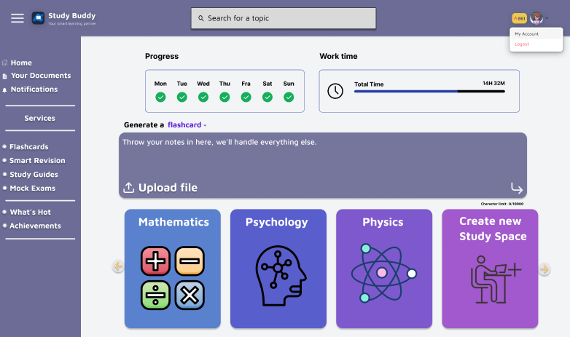

Appendix D – Data Tables and Charts

Solo Taxonomy
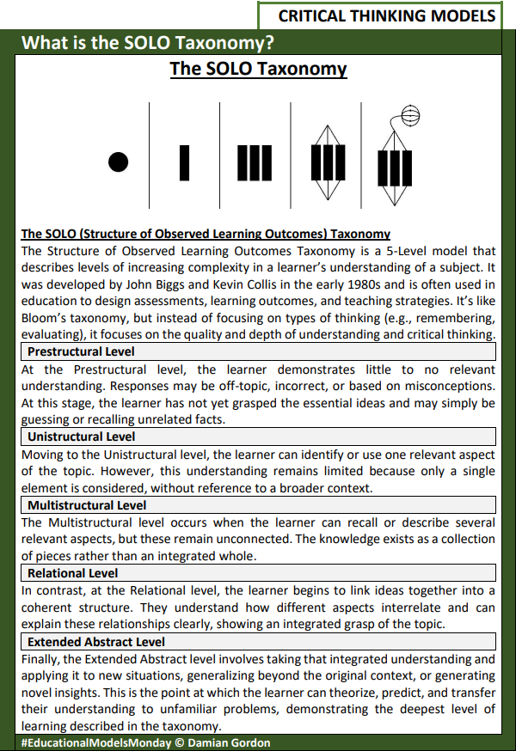

Appendix E – Future Testing

Cognitive Task Completion / Time Taken
There are numerous metrics with set target goals; for example, the cognitive tasks should be completed, and be done so within a set timeframe (< 2 minutes) for success in two criteria.
 |  |  | Task Completion / Time Taken
 | Task 1 |  |  | Task 2 | Task 3 | Task 4 | Task 5
User 1 | y/ 5s |  |  | y/ 18s | y/ 2s | n/ ()s | y/ 53s
User 2 | y/ 13s |  |  | y/ 29s | y/ 7s | y/ 32s | y/ 86s
Table 11: Sample Task Completion & Time Taken
The table above showcases the cognitive tasks being completed (y) or failed (n) along with the time required for the task (e.g., 53s for Task 5).

Appendix F – Survey
https://docs.google.com/forms/d/1CQ-nFRwg1R7YiGxtQ-caQfJ5R-Q3z7q-p85x7RnwJlc/

